

10 – 17 April 2025

Event

Resource Kit



# 

# It takes a Tasmanian Village: Child and Youth Wellbeing Strategy

# Tasmania’s [Child and Youth Wellbeing Strategy](https://wellbeing.tas.gov.au/download_file/view/1147/533) is shaped by the voices of children and young people, and those who care about them and their future.

# Tasmanians shared their hopes and dreams for all children and young people in our State and this feedback inspired the title of the Strategy ‘*It Takes a Tasmanian Village’*, along with our vision, and a set of 10 principles which, today guide the way we work as we implement the Strategy.

# In 2025 the Child and Youth Wellbeing Team will be responsible for the co-ordination of Youth Week Tasmania.

# For further information

# [It Takes a Tasmanian Village....](https://wellbeing.tas.gov.au/)

# [hello@wellbeing.tas.gov.au](mailto:hello@wellbeing.tas.gov.au)

# Welcome to Youth Week Tasmania 2025!

Thank you for your enthusiasm to plan and hold an event during Youth Week Tasmania (YWT) 2025!

Each year, YWT event holders are provided with information and advice that supports you to promote your event and encourage participation.

This kit aims to get the basics into your hands and make planning and promoting your event as easy as possible.

Including the voices of Tasmanian young people is a top priority for the Tasmanian Government and the Tasmanian Child and Youth Wellbeing Strategy. We encourage you to include young people in planning and running your event. We’ve included a guide to co-design—a simple process that makes sure you’re including young people at each step.

The full contents of this kit are listed on the next page.

If you would like further advice or can’t find the information you need contact the wellbeing team at [hello@wellbeing.tas.gov.au](mailto:hello@wellbeing.tas.gov.au)

.

**What’s inside:**

Welcome to Youth Week Tasmania 2025! 3

About Youth Week Tasmania 5

How to include the voices of young people in your event 6

How to promote your event 8

How to use the Youth Week Tasmania 2025 and supporter logos 10

How to contact media about your event 13

# About Youth Week Tasmania

Aim

The aim of YWT is to celebrate and highlight the invaluable contributions that young Tasmanians aged 12-25 years make in their communities.

YWT also aims to showcase the extraordinary talents and skills of young people, as well as provide them with a platform to engage with their communities, and express concerns, ideas, and views relevant to them.

Theme

The YWT theme changes each year. This year’s theme is **‘Courage: Stepping out of your comfort zone’**.

The 2025 YWT theme was developed based on feedback from 2024 YWT participant and stakeholder surveys and ongoing conversations with young people.

The theme strongly reflects the aim of YWT. It was chosen by young Tasmanians to acknowledge their important place in Tasmanian communities. There was agreement that through this theme young people could explore special talents and the theme could extend to teachers and other adults stepping out of their comfort zones.

Facts and stats

* YWT has been running since 2018 after the Australian Government discontinued *National Youth Week*.
* There were 10 YWT events held in 2024, organised by local councils and other community organisations in collaboration with Tasmanian young people, and by young people themselves. In 2025, 16 events are being held.

The 2025 Youth Week Tasmania Grants Program is being coordinated by the Department of Premier and Cabinet with support from the Youth Network of Tasmania.

Safety

We are committed to ensuring the safety of all children and young people attending activities and events during Youth Week Tasmania. Organisations running activities and events during Youth Week must comply with the Child and Youth Safe Organisations Framework and the *Registration to Work with Vulnerable People Act, 2013*.

# How to include the voices of young people in your event

###### Young people and co-design

Co-design in youth work elevates participatory and engagement models by empowering young people to be actively involved in decision-making processes.

###### How does co-design differ from participation?

Not all participation is co-design. Co-design involves all parties sharing decision-making power, not simply acting in an advisory or consultative role.

###### Why use co-design?

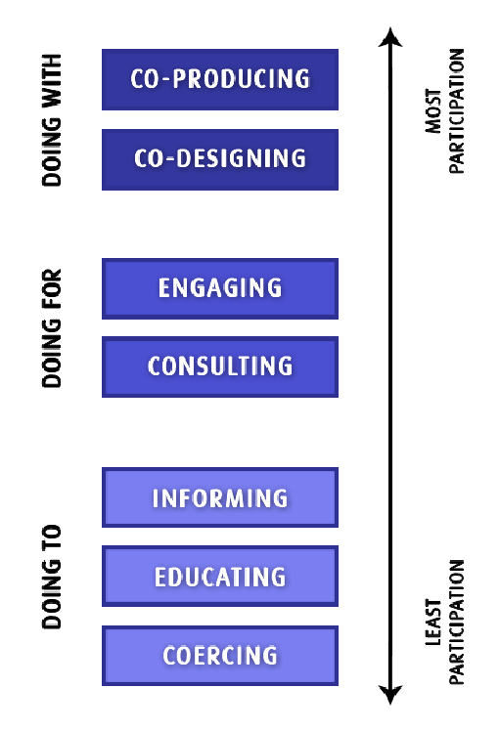

Co-design helps youth services to create services, programs or initiatives with the end-user considered at all stages of development, delivery, or review. Benefits include:

* More effective service provision
* Better buy-in from service users
* Increases trust with service users
* Makes services more responsive to client needs
* Better services with improved wellbeing outcomes

###### The principles of co-design

There is no step-by-step guide to co-design. Good co-design should:

* Give equal value to lived experience vs profession or education
* Share decision-making power between members
* Support active participation and involvement
* Build capacity and capability of members

**Tips for good co-design with young people**

* 1. Be purposeful

Be able to explain the purpose of the co-design process and their role in the process.

* 1. Be meaningful

Take the time to seek, discuss and consider their input.

* 1. Be genuine, not tokenistic

Give genuine opportunities with substance, purpose and power – don’t just ‘tick a box’.

* 1. Be respectful

Develop trust and mutual respect, consider them as equal partners in the process.

* 1. Be inclusive

Ensure the group supports all people to participate, including people from diverse backgrounds and experiences - not just those who are already engaged in the community.

* 1. Create a safe space

Actively create a safe, inclusive space that supports diverse needs.

* 1. Be flexible

Consider appropriate ways for them to be involved that doesn’t negatively impact their

personal, school or work commitments.

* 1. Identify and remove barriers

Ask what may hinder their participation and work together to find solutions.

* 1. Be mutually beneficial

Ensure members get a positive outcome from participating, such as personal and skill development.

* 1. Appropriate remuneration

Compensate them for their time, skills and expertise.

* 1. Support their involvement

Regularly check in with members, encourage their participation and adapt as needed.

* 1. Provide resources

Guarantee equal access to information and resources needed for members to be informed and prepared.

* 1. Provide opportunity for feedback

Ask for their feedback on how to improve the co-design process.

* 1. Involve the team in evaluation

Close the co-design loop with a final evaluation and include their feed

# How to promote your event

The key to the success of any event is promotion. Good publicity before your YWT event will help to increase attendance on the day, improve volunteer participation and attract media coverage.

### Promoting your event with and to young people

Young people are the experts in how best to communicate and promote information to each other. Some ways to involve young people with your event are to:

* Collaborate to gain ideas about the best ways to promote your event to young people and the wider community.
* Involve young people in the design and creation of flyers, posters, banners and other promotional material listing event details and ask them where they think the best locations are to put them up within the local community.
* Encourage young people to promote YWT and your event through word of mouth within their schools, families, friends, community networks, and other groups.
* Encourage young people to promote the event through social media.
* Young people could be involved in promoting the event through an interview on a local radio station or by creating an advertisement to be played on-air or advertised in a local newspaper/gazette.

### Accessibility and promotional materials

Accessibility in promotional materials refers to designing and creating content in a way that ensures it can be accessed and understood by people with varying abilities and barriers. Here are some tips for creating accessible promotional materials:

* **Use accessible fonts and colors:** Use fonts that are easy to read and choose colors with sufficient contrast to ensure that the text is visible. Avoid using colors that are too bright or too light.
* **Add alternative text** to images, graphs, and charts so that people who use screen readers can understand the content. Alternative text should be descriptive and provide the same information as the image.
* **Provide captions and transcripts** for videos and audio content. This will ensure that people who are deaf or hard of hearing can understand the content.
* **Avoid flashing or blinking content** as it can trigger seizures in people with photosensitive epilepsy.
* **Use simple and easy-to-understand language** in your promotional materials. Avoid using jargon, complex sentence structures, or technical terms.
* **Use accessible formats:** Consider providing your promotional materials in accessible formats such as Braille, large print, or audio.

For a more in-depth resource on digital accessibility, see this guide: <https://accessibility.huit.harvard.edu/content-creators>

Use your existing communication and promotion methods and collaborate with other services

* Display various promotional material in and around your organisational space.
* Include event details in your organisation’s newsletter, calendar or bulletin board display space.
* Provide information to local schools and services to include in their newsletters, online platforms and to display in their physical spaces i.e., a poster promoting your event.
* Send out event information via email contacts and networks and send personal invitations to individuals, schools and organisations who you think may be interested in attending.
* Advertise the event through any social media platforms you have. **Don’t forget to tag @YWTas and use hashtags #YWT2025 and #YouthWeekTAS.** Including a Google Map for the event location could also be useful.
* Post on local community noticeboard social media groups
* Consider posting on local event registers, such as on your local radio station’s website.
* Create an event on Facebook and encourage attendees to share the invitation.
* Include event information on your organisation’s website and provide a link to the [YWT website](http://www.ynot.org.au/ywt) <https://www.ynot.org.au/young-people/youth-week-tasmania>

Other ways to promote your event

* Email your event details and promotional material to the Wellbeing team hello@wellbeing.tas.gov.au . More details on creating promotional material are available in this package.

We will coordinate with YNOT who will promote your event via:

* YNOT website YWT event calendar <https://www.ynot.org.au/news-events/whats>
* YWT Facebook page <https://www.facebook.com/ywtas/>
* YNOT Instagram page <https://www.instagram.com/ynot_tas/>
* Statewide media opportunities.

The wellbeing team will also promote your event on <https://wellbeing.tas.gov.au/strategy>

* Prepare a media alert with information about when and where your event is happening. You can also publish this information on your website and share it on social media so it can be accessed before, during and after the event. Tips for writing a media alert as well as the link to an editable template are available in this kit (see last page).
* The media alert is used to let the media know that your event is happening, why it will be of interest to their audience, who they can interview and the types of activities they can photograph or record to use with their stories.

## How to use the Youth Week Tasmania 2025 and supporter logos

The YWT 2025 logos are available in jpeg format in this guide for use by anyone intending to hold a YWT 2025 event or activity, in accordance with these guidelines. If you require the logos in an alternative format, don’t hesitate to contact the wellbeing team at [hello@wellbeing.tas.gov.au](mailto:hello@wellbeing.tas.gov.au) .

‘Acknowledging Tasmanian Government support’ logos should **only** be used by YWT 2025 grant recipients for events supported by the Tasmanian State Government through the Department of Premier and Cabinet grants program. [Link to Acknowledging Tasmanian Government support logos.](https://www.tas.gov.au/communications/toolbox/acknowledging-tasmanian-government-support)

All YWT 2025 grant recipients must follow the mandatory guidelines when using Tasmanian Government logos. This information has been provided in the ‘Acknowledgement of Funding’ annex in your YWT grant agreement.

Guidelines for using the Youth Week Tasmania 2025 logo

As a YWT 2025 event, you must use the official logo on all promotional materials to make sure people know your event is a YWT event, supported by the Tasmanian Government.

The official YWT 2025 logo must be included in the main body of any posters or promotional items you produce. **Do not put it in a strip of other supporter or sponsor logos relating specifically to your event.**

We have provided both horizontal and vertical logo designs as well as a choice of black and white, and colour versions of the logo. Please use the one that works best for the materials you are producing.

Dos and Don’ts of Youth Week Tasmania 2025 logo use

For ALL YWT event organisers**:**

* **Do** always include the YWT 2025 in all public promotion and information materials supporting your event.
* **Don’t** make the YWT 2025 logo smaller than 25mm wide for the vertical version, and 50mm wide for the horizontal version.
* **Don’t** change the format, colour, shape or font of the logo
* **Do** drag the logo from the corners to resize it. This will make the height and width change in proportion, so it is not squeezed, squashed or otherwise distorted.
* **Don’t** create your own version of the logo by adding or removing any text or part of the logo.

For YWT 2025 grant recipients ONLY:

Do also include the Tasmanian Government ‘supported by’ logo in all public promotion and information materials supporting your event.

Do get approval from DPAC before distributing promotional material

Horizontal logos available for use



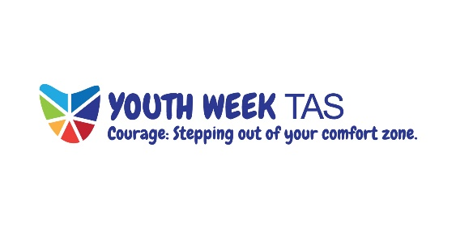

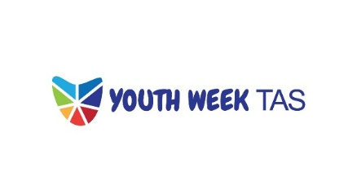

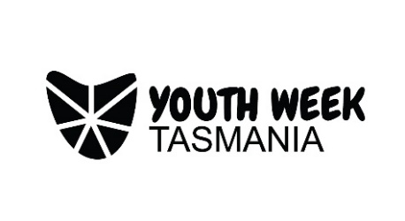

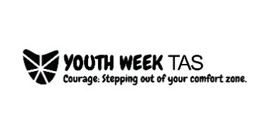

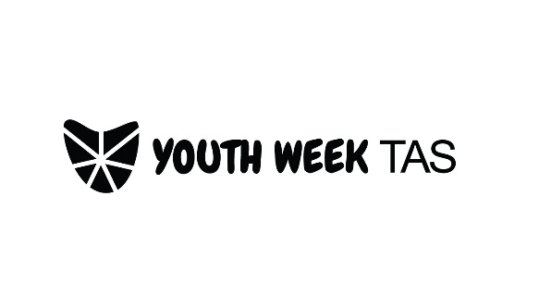

**Vertical logos available for use**

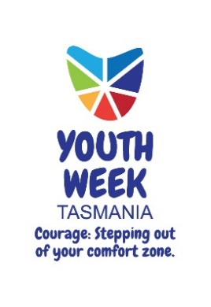

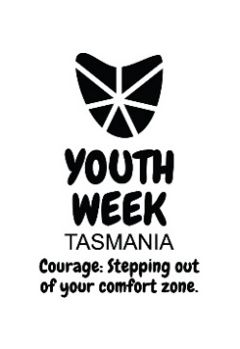

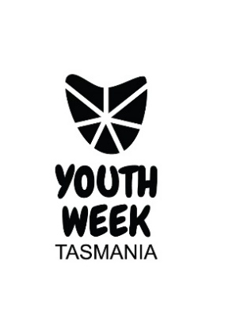

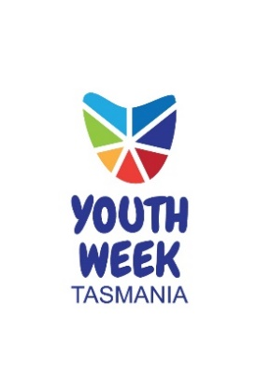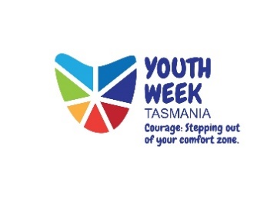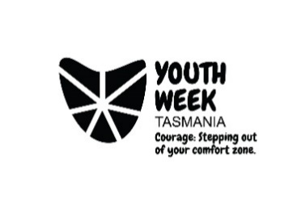

###### YWT 2025 grant recipients must get approval before distributing promotional material

All promotional material using Tasmanian Government logos must be approved by the State Government prior to publication.

To get approval please:

* Send the promotional material to Department of Premier and Cabinet for logo approval via email to [grants@dpac.tas.gov.au](mailto:grants@dpac.tas.gov.au).
* Ensure you send the materials saved as.jpeg, .png, .pdf or Microsoft Office-based file formats (such as Word, PowerPoint and so on).
* Please CC [hello@wellbeing.tas.gov.au](mailto:hello@wellbeing.tas.gov.au) into the email.

Plan for the logo approval process to take five working days.

You will receive an email notification from the Department of Premier and Cabinet when logos are approved for use. Approval is only for the use of the logo as requested in your submission. That means that if you alter your promotional materials, you may need to request logo approval again.

Please contact [grants@dpac.tas.gov.au](mailto:grants@dpac.tas.gov.au) for more advice on this process.

#### When your promotional materials are approved and ready to go…

Check that [hello@wellbeing.tas.gov.au](mailto:hello@wellbeing.tas.gov.au) was included in the email you received notifying approval of your promotional material – if not, please forward the email to this address. Provide a brief description of your event so we can let everyone know what you’ve got planned. Include a link to the Facebook event or ticketing platform (if relevant).

YNOT will also help promote your event by sharing them across the YNOT networks statewide.

# How to contact media about your event

The best way to let the media know about your event is to prepare a **Media Alert** that you can post on your website, email to specific media outlets, and share on social media.

A Media Alert is a simple and concise set of paragraphs that includes:

* One or two sentences explain why the event is of interest to the media’s audience (Will your event produce something creative, or does it take an innovative approach? Is the first-time something like it is being done in your area? Does it involve local people?)
* A description of the kind of activities TV cameras and photographers can get to accompany the story if they visit your event
* The who, what, why (as part of YWT 2025!), when and where of your event
* A contact name and phone number for one of the event organisers in case journalists want more information or to arrange a visit before or after the event, and
* The YWT 2025 and Tasmanian Government logos.